Write a program of Vacuum cleaner using python code

Aim :To implement the Vacuum Cleaner Problem using Python..
Procedure:
Define the initial state of the two rooms (A and B).
Check whether the current room is dirty.
If dirty, clean it.
Move to the other room.
Repeat until both rooms are clean.

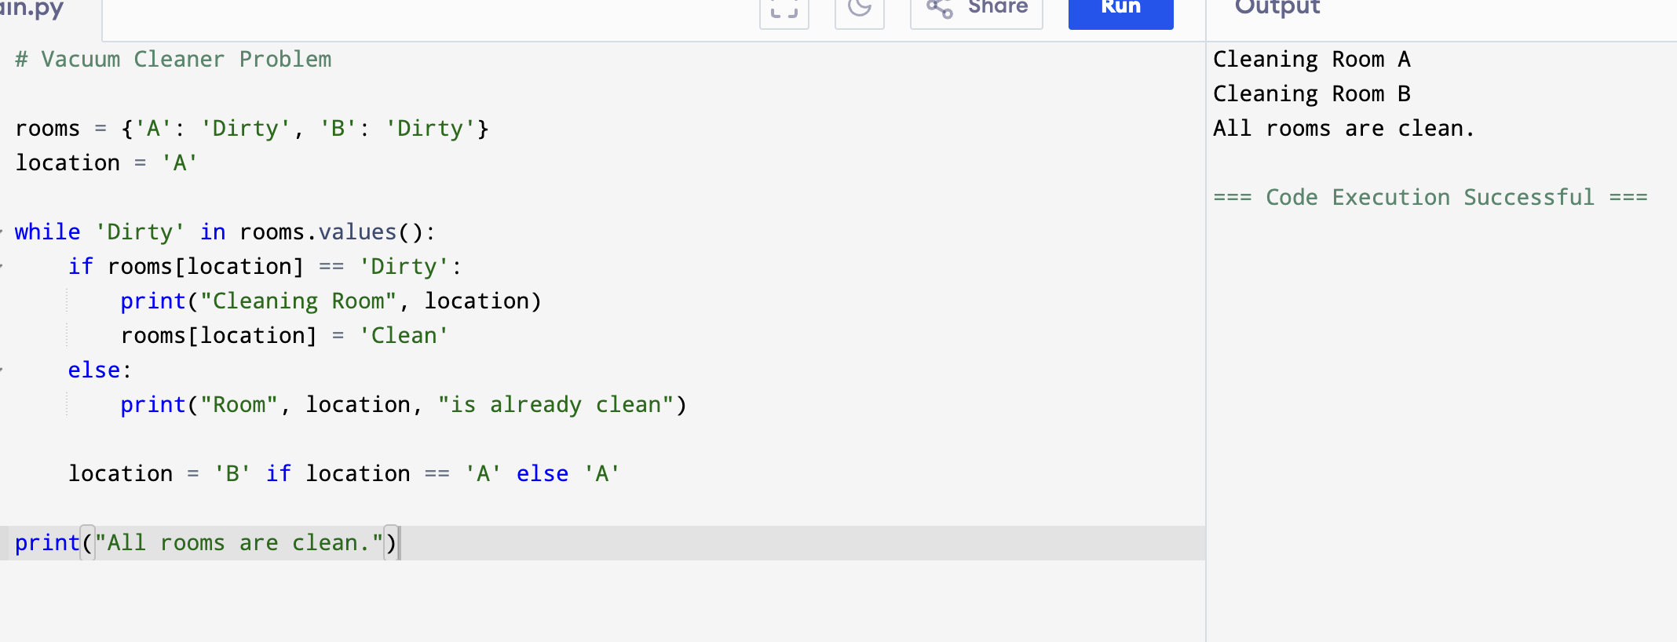
Output:

Result: Hence, Vacuum Cleaner problem has solved

